

Aug, 18, 2014

**Ahoy Thar!**

**Room 105 Newsletter**

Parents/Guardians,

Students had a lot of fun this week getting to know each other, learning the routines, and getting into the swing of learning! Wow! We are off to reading, writing, solving math problems, and learning social studies.

I hope that your child had an exciting week of learning and adventure! As an educator, the beginning of the school year is one of my favorite times. I am very impressed! The class has done exceptionally well in following the rules and norms of the classroom and in and out of the school. We have had several compliments and feel very proud of ourselves.

Thank you to all the parents who have filled out all the paper work and have helped your children to complete the first week of homework.

This week we will have our first spelling test on Friday. Attached are the directions for how spelling is “run” in the classroom.

If you have any questions or concerns, please do not hesitate to contact the school or either myself.

Have a great week!

Mrs. Reed ☺

**Treasured Events:**

**Friday – Spelling Test**

**9/19** Field Trek

**9/16** Open House 5:30-7:00

**10/2** Fall Festival

***Choices*:**

**Choice 1**: Put your words in alphabetical order.

**Choice 2**: Draw a picture and hide your words in the picture.

**Choice 3**: Write your words 3 times each.

**Choice 4**: Write your word and tell how many syllables are in each word.

Spelling Words

1. ability
2. active
3. community
4. absorb
5. multiplication
6. urban
7. accuse
8. factor
9. suburban
10. act
11. product
12. rural

MC900295588[1]MC900295588[1]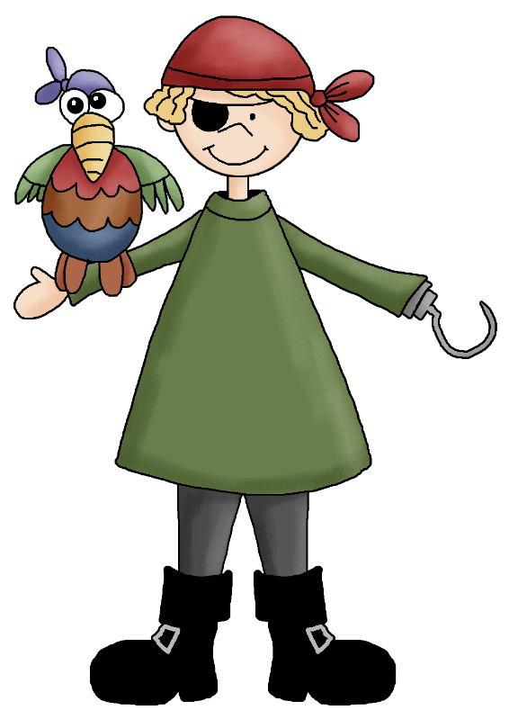

**Cool to Care Announcements** –

Inside your child’s agenda are Cool to Care Awards that they can write so that I can give to Mrs. Rivera during Morning Meetings in the gym.

What we’ve been doing in the classroom-

**Reading**: We read two texts, *David Goes to School* and *Fine, Fine School*. We learned how complex text is organized: word, sentence, paragraph, segments, whole text and two texts. Students then sorted questions and identified them, creating arguments to justify their positions. Students also answered oral text based questions. Students then self selected 6 books and worked on their stamina in reading them.

**Math**- I worked with students to learn to interpret products in multiplication as groups of and to identify structures/patterns in the 2’s on the 100 chart.

**Writing** – Students completed a heart map and then learned about synonyms. They then wrote synonym words for the word – said and pasted them as a resource page.

**Social Studies-** Students reviewed what they knew about communities. They then learned what a urban, suburban, and rural community was. They also brainstormed rules in the different settings throughout the school. Currently they are constructing their own community to continue their understandings of the government unit we are currently working through by making a diorama.

**Homework for Week 2**:

|  |  |
| --- | --- |
| **Monday**  Spelling  Reading Text & Questions | **Tuesday**  Spelling  Math - Multiplication |
| **Wednesday**  Spelling  Reading Text & Questions | **Thursday**  Spelling  Math - Multiplication |
| **Friday**:  Take home agenda and make sure it has been signed. | | |